**NewsWatch App**

**Aim**:  
To design an interactive mobile app that allows users to access news, create and post updates, and personalize their experience with user-friendly navigation and features.

**Procedure:**

**STEP 1**: Create a new project and set up frames for each screen (Sign Up, Sign In, Forgot Password, Settings, Create News, Profile, and City Selection).  
**STEP 2**: Set background colors, grids, and guides for consistent alignment.  
**STEP 3**: Add text, images, buttons, icons, and form fields on each screen.  
**STEP 4**: Design interactive states for form fields, buttons, and links to enhance user interaction.  
**STEP 5**: Link frames together to allow navigation between screens and preview the prototype to test functionality.

**Diagram**:

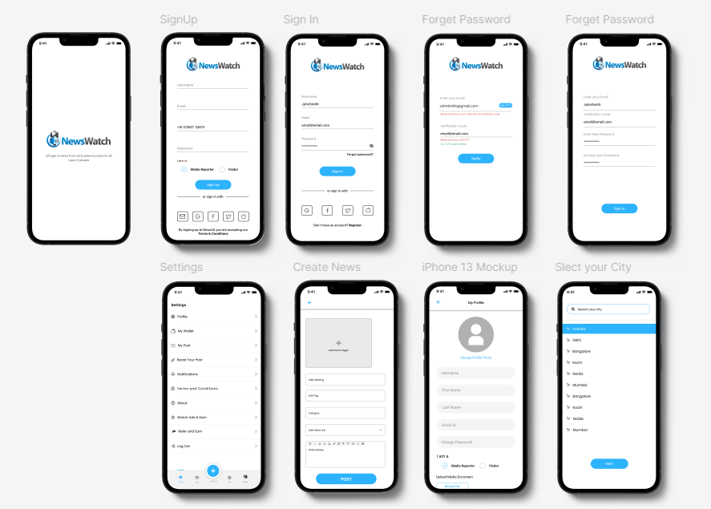

**Result**:  
A visually appealing and easy-to-navigate mobile app prototype that allows users to engage with news content, customize their profiles, and seamlessly interact with the app's features. This design promotes user engagement by providing a smooth and intuitive experience for accessing and sharing news.